The European Cultural Heritage: Europe, Heritage, Startup!

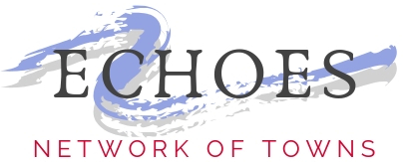

Name of the team: Municipality of Cajetina
Name, Surname of the leader: Vera Blagojevic
Number of members: 3
Age of the members: 23, 32,38
Town/s: Cajetina
Country:Serbia
_____________________________________________________________________________________________

(TITLE OF THE INITIATIVE)

Description of the initiative (Max 5.000 characters)

We want to launch an initiative to re-hold the manifestation "Serbian New Year's Eve" in the village of Jablanica, which is located in the municipality of Cajetina, southwestern Serbia. Until two years ago, this event was held, which aimed to meet the young inhabitants of the village, but also many young and older tourists who come from the tourist place Zlatibor to visit this event with the traditional values ​​and customs of this area. This event would be held every January 13, when according to the Julian calendar, Serbs who are of the Orthodox faith celebrate the New Year. On January 10, 1919, the Kingdom of Serbs, Croats and Slovenes accepted that the official calendar should be Gregorian, but Orthodox Serbs still celebrated certain holidays according to the Julian calendar, because they believe that it is the original calendar.
This event gathers villagers and guests who come that day to the village aged 2 to 82, is held next to Orthodox churches, in the forest of centuries-old pine trees, illuminated by floodlights and so lit and under the snow create the impression as if they were in a fairy tale. The event is designed to have a cultural program during which Serbian traditional songs are performed, folk dances, and then Christmas Bata appears who comes with a bag full of gifts for children and he tells Christmas stories about customs related to Christmas and Serbian New Year. A year. The children listen attentively, and then he asks them to recite a song about tradition, Christmas or winter. A child who sings a few verses receives a gift. Later, with the sounds of the trumpet, a traditional dance is played - kolo. And there will always be a beautiful fireworks display that young people look forward to the most in that ambience.
Two years ago, this event stopped being held because the previous organizers fell ill, and later the Kovid period began, and this event was not held the previous year either. All the inhabitants of the village want the manifestation to continue, but they need help in the organization.
Why do you want to implement this initiative?
Thus, an event that promotes traditional values ​​is important for children and young people to learn in a fun way about their customs and traditions. In addition, children and young people in rural areas do not have the opportunity to attend a sufficient number of cultural events. And that is why we want to re-launch the initiative for holding these Manifestations, but in a new spirit, where, in addition to the listed cultural contents, we would also organize a play for children with elements of cultural heritage. But they also organized a quiz with interesting questions on the customs of this area that they could previously learn during the event, and for the winners would provide nice gifts consisting of classic souvenirs of this village, because the event is represented by young people from other parts of Serbia. on wintering on the nearby mountain Zlatibor.

What needs will you meet?
We will enrich the knowledge of children and youth, and we will primarily provide quality facilities for children and youth living in this village. Thus, they will have the opportunity to meet their peers who come from different parts of Serbia, Bosnia and Montenegro.

What would you like to understand and why?
In this way, we want to find out how much young people are interested in such and similar contents, so that in the future we can try to organize even more similar contents in this, but also in other villages. To understand through interaction with grandparents and young people what they are missing in terms of cultural content, and in which they themselves would like to participate in the future.

How long would your initiative last?
We want this event to be held every January 13 in the coming years, in the village of Jablanica, but also to expand it to other villages.

What are the main goals, objectives? Please also use some indicators that could help assess the initiative and its feasibility.
Our main goal is for our children to learn the customs with which they lived the preconditions, and to gain interest in traditional values, as well as to get involved in such events as participants and later as organizers. The specific goal is reflected in the desire to enrich the cultural content of children in rural areas.
If we realize this initiative, and re-organize the Serbian New Year's Eve with new content, we are sure that the event will start with at least 100 children and youth from 2 to 25 years, mostly residents of this village, but also guests coming from abroad. At least 30 young people will take part in the recitation program, and at least 20 young people will take part in the quiz. In addition to children and young people, this event will be attended by at least 300 adults and guests.

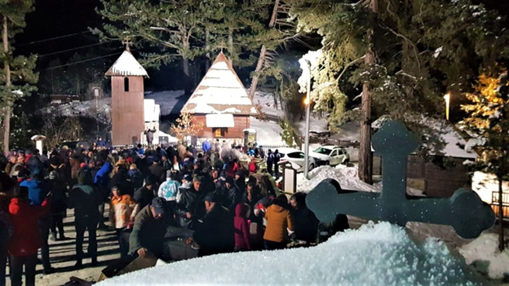

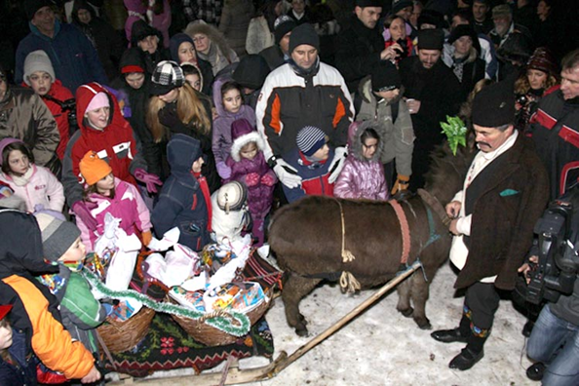

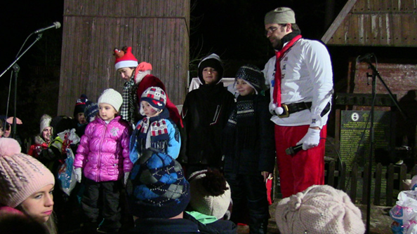

3 photos from the event, which was held earlier and for which we are launching an initiative to reorganize.
Please attach 1-2 pictures/paintings/link to a video…., something which could clarify the state of the art and what you would like to realize.

